

SIMATS ENGINEERING

Saveetha Institute of Medical and Technical Sciences
Chennai- 602105

Student Name: Abinesh H Reg. No.: 192424387
Course Code: DSA0306 Slot: C
Course Name: Natural Language Processing
Course Faculty: Dr. Kumaragurubaran T
Project Title: Natural Language-Based Insider Threat Detection from Enterprise Communications
Module Photographs: (3 photographs –Module Photo, Individual student contribution module work in the project and presentation image)
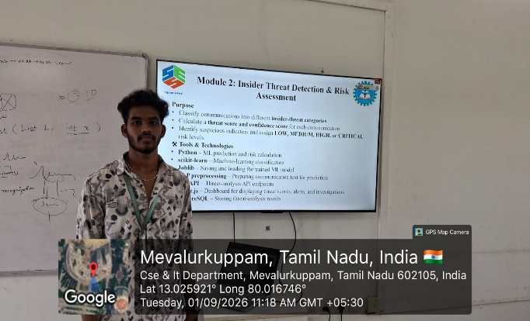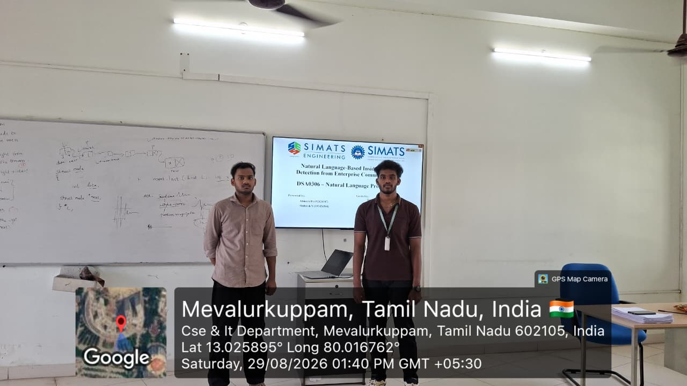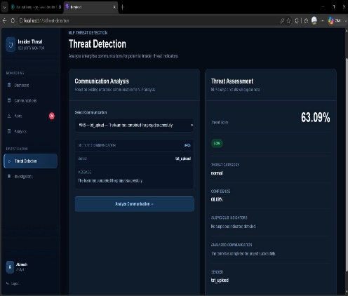
Review – 1 Review – 2 Module - 2
Project Description:
This project focuses on the design and implementation of a Natural Language-Based Insider Threat Detection system for identifying potential security threats from enterprise communications. The objective is to develop an intelligent system that analyses communication patterns and detects suspicious or abnormal activities. In Module 1, enterprise communications are collected and processed using Natural Language Processing (NLP) techniques to clean the text, remove irrelevant information, and extract meaningful features. Module 2 analyses the extracted features using machine learning techniques to identify suspicious behaviour and assess the associated risk level. The system helps distinguish normal communication from potentially harmful or unusual activities. It also supports the identification of high-risk users and communication patterns that may require further investigation. Finally, Module 3 provides a security monitoring dashboard for displaying detected threats, risk levels, alerts, and user activities. Security administrators can monitor alerts, prioritize critical incidents, and investigate suspicious communications through the dashboard. The system provides useful insights that can support faster threat identification and security decision-making. It also helps organizations improve their internal security monitoring and reduce the impact of potential insider attacks. Overall, the proposed system provides an efficient, intelligent, and automated solution for detecting, assessing, monitoring, and investigating insider threats in enterprise communication environments.

Student Signature Guide Signature

